CPE301 – SPRING 2019

Design Assignment 3A

Student Name: Clayton Higbee

Student #: 5001189864

Student Email: higbee@unlv.nevada.edu

Primary Github address: <https://github.com/claytonjhigbee/CODSWORTH_MAIN>

Directory:

1. **COMPONENTS LIST AND CONNECTION BLOCK DIAGRAM w/ PINS**

Components used:

Atmega328P Xplained Mini Board

Female to Male Wires (For logic analyzer Connections)

Logic Analyzer

FTDI Basic Breakout board (RS232 to TTL)

Breadboard

Block Diagram with pins used in the Atmega328:

PD0(Rx) -> RxI

PD1(Tx) -> TxO

PC6(Reset) -> DTR

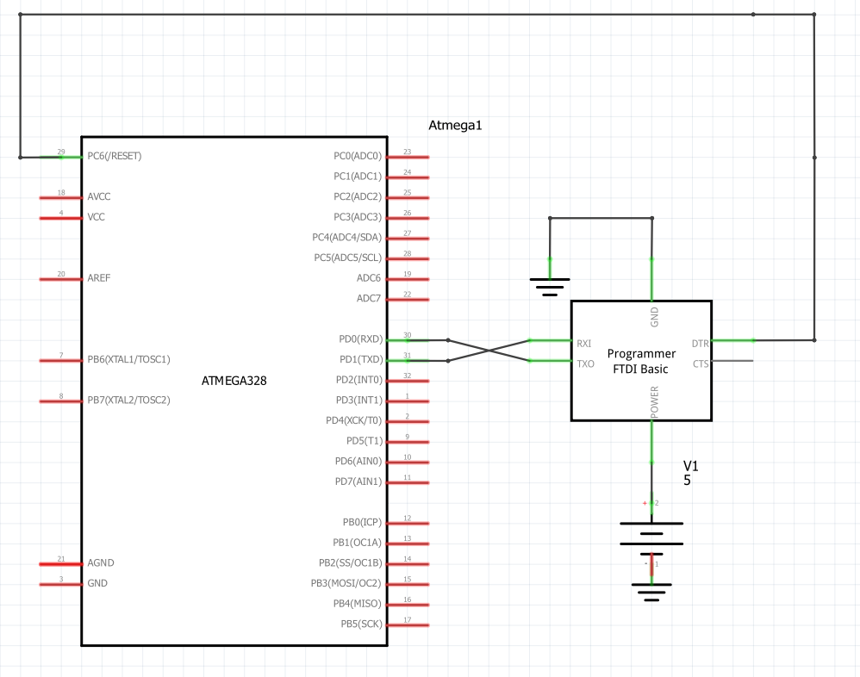

1. **INITIAL/MODIFIED/DEVELOPED CODE OF TASK 1/A**

/*

* SerialReaderProgramV2.c

*

* Created: 3/26/2019 3:08:03 PM

* Author : clayt

*/

#define *F_CPU* 16000000UL

#include <avr/io.h>

#include <util/delay.h>

#include <avr/interrupt.h>

#include <stdio.h>

#define BAUDRATE 9600

#define BAUD_PRESCALLER (((*F_CPU* / (BAUDRATE * 16UL))) - 1)

// Function Declarations

volatile int OVFCount; // initialize global overflow counter variable

void USART_init( unsigned int ubrr );

void USART_tx_string( char *data );

char outs[25];

int mynumber;

char str[] = "SUP";

char empty[] = " ";

float hernumber = 27.3653442500000003;

int main(void)

{

OVFCount = 0; // initialize Overflow counter

OCR0A = 220; // Load compare Reg Value

TCCR0A |= (1<<WGM01); // Set to CTC Mode

TIMSK0 |= (1<<OCIE2A); // Set interrupt on compare match

TCCR0B = 0b101; // Set prescalar to 1024 and starts PWM

sei(); // Enable Global Interrupts

USART_init(BAUD_PRESCALLER); // Initialize the USART

USART_tx_string("Connected!\r\n"); // Send initial connection print for verification

while(1)

{

// Get three desired values

// First Desired Value, Print a string

USART_tx_string(str); // Print SUP

USART_tx_string(empty); // Print empty space

// Second Desire value, Print a random integer

mynumber = *rand*();

*snprintf*(outs,sizeof(outs),"%3d\r\n", mynumber); // print it

USART_tx_string(outs); // Print random integer number

USART_tx_string(empty); // Print empty space

// Third desired Value, Print a floating point number

*sprintf*(outs, "%g", hernumber);

//snprintf(outs,sizeof(outs),"%3d\r\n", hernumber); // print it

USART_tx_string(outs); // Print random integer number

USART_tx_string(empty); // Print empty space

OVFCount = 0; // initialize Overflow value for this button press

TCNT0 = 0x0; // Reset Timer for Delay

while(OVFCount < 71)

{

// Do nothing O.o, waiting for entire overflow count to occur

}

}

}

// Continue to increment counter until it reaches 77, then turn LED off

ISR(TIMER0_COMPA_vect){

OVFCount++; // Increment overflow flag counter

}

/* INIT USART (RS-232) */

void USART_init( unsigned int ubrr )

{

UBRR0H = (unsigned char)(ubrr>>8);

UBRR0L = (unsigned char)ubrr;

UCSR0B = (1 << TXEN0); // Enable RX, TX & RX interrupt

UCSR0C = (3 << UCSZ00); //asynchronous 8 N 1

}

/* SEND A STRING THROUGH RS-232 BY FTDI BOARD*/

void USART_tx_string( char *data )

{

while ((*data != '\0'))

{

while (!(UCSR0A & (1 <<UDRE0)));

UDR0 = *data;

data++;

}

}

1. **DEVELOPED MODIFIED CODE OF TASK 2/A from TASK 1/A**

No modified code, only one task required.

1. **SCHEMATICS**



1. **SCREENSHOTS OF EACH TASK OUTPUT (ATMEL STUDIO OUTPUT)**

Serial Output at COM Port from FTDI:

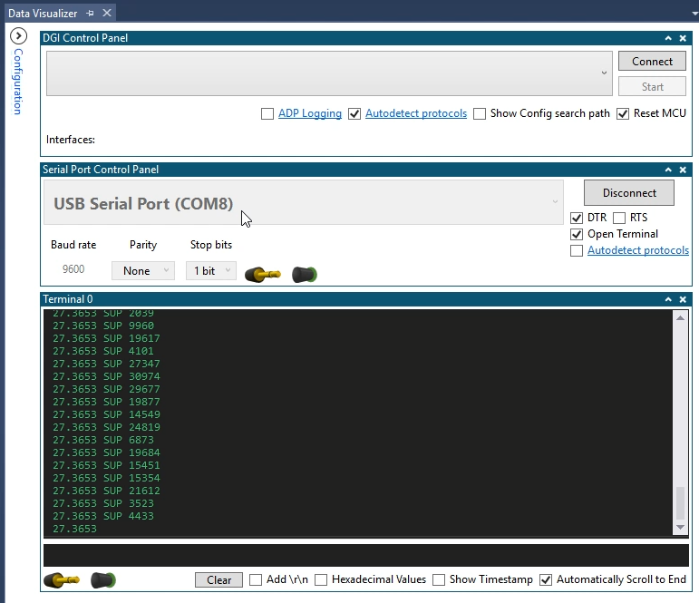

Output Waveform showing the print occurring every 1 sec.

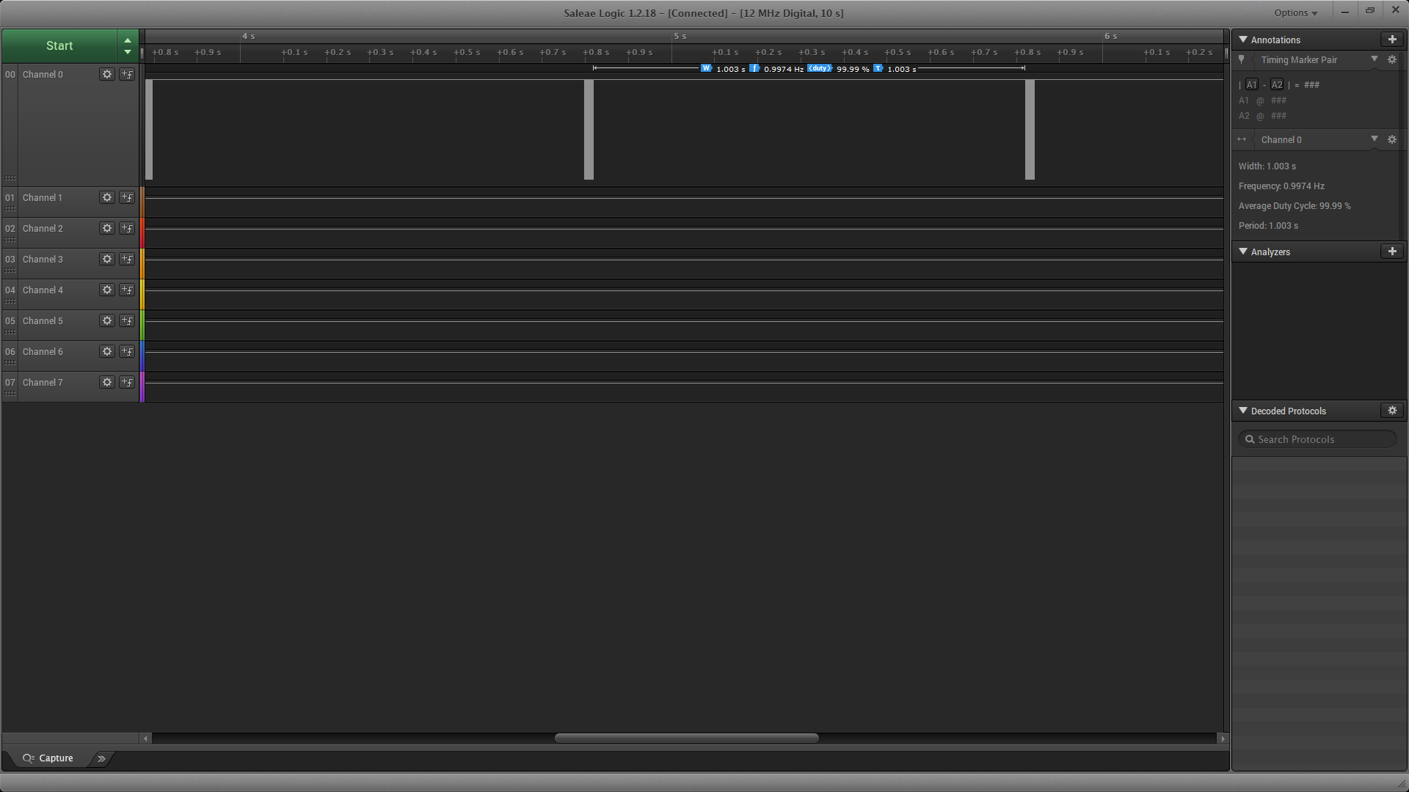



1. **SCREENSHOT OF EACH DEMO (BOARD SETUP)**

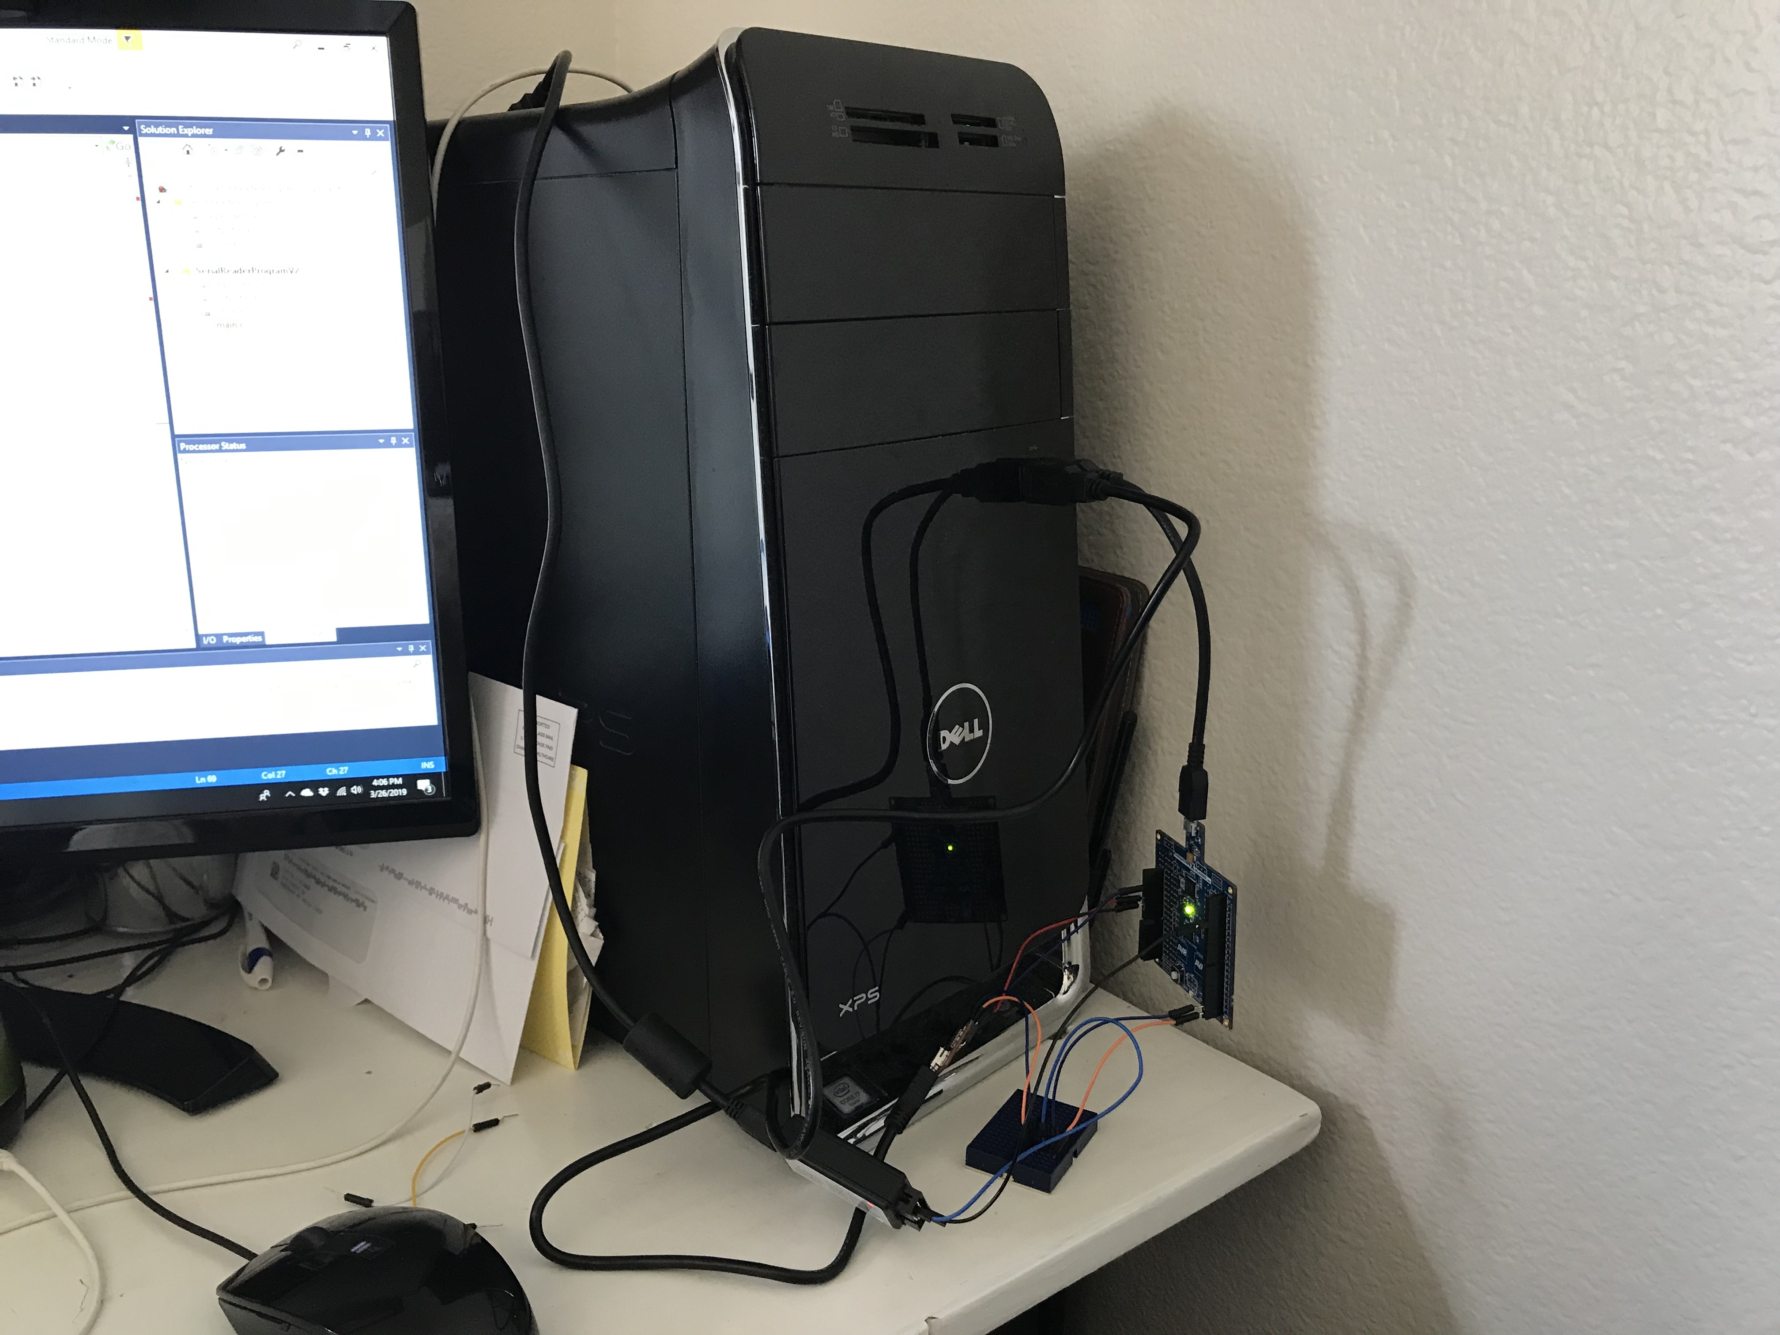

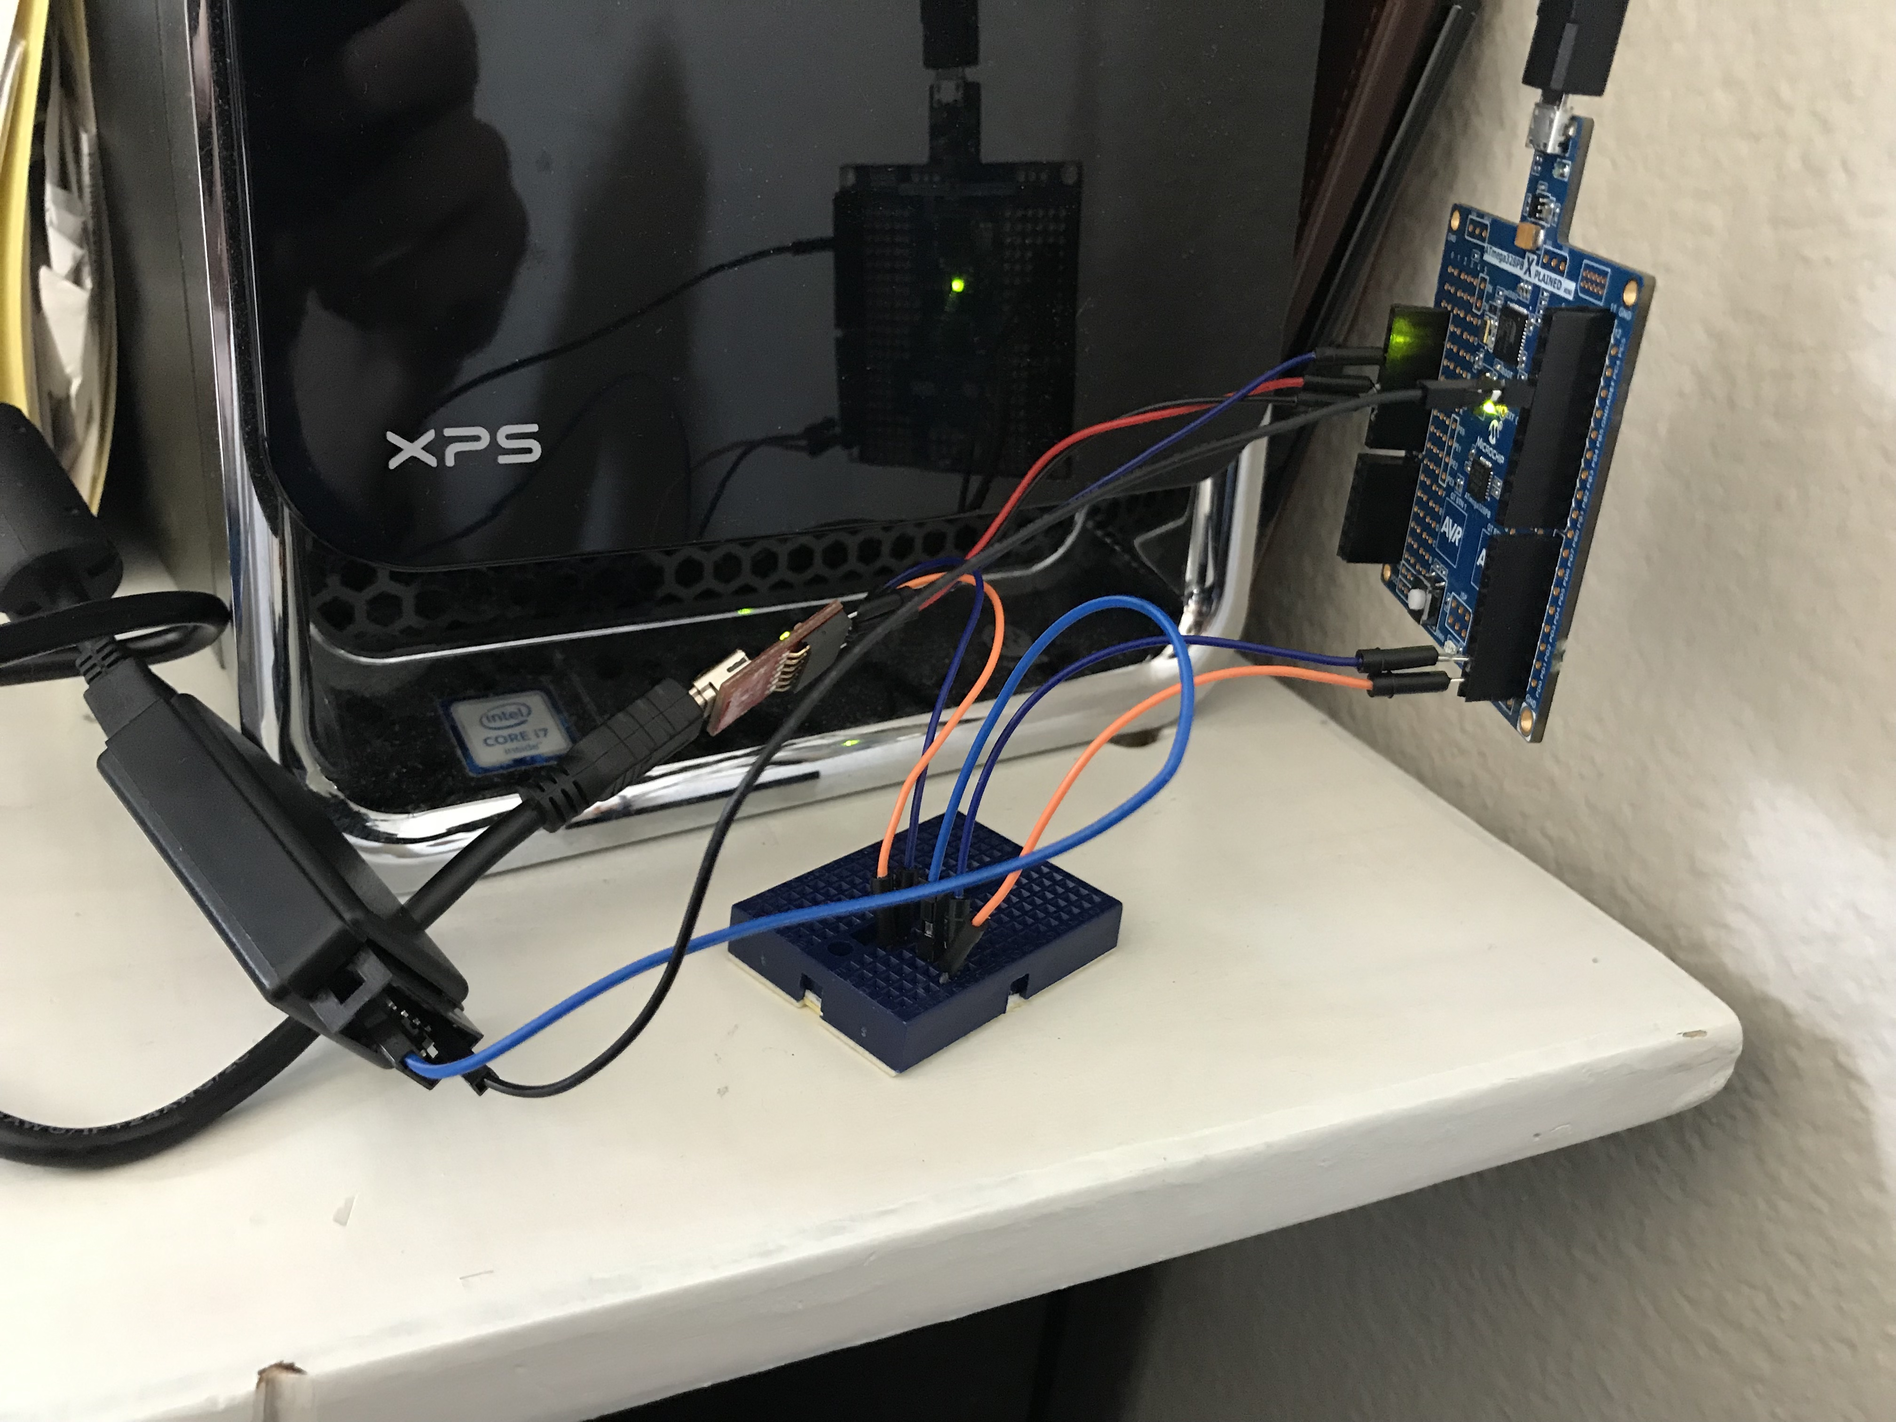

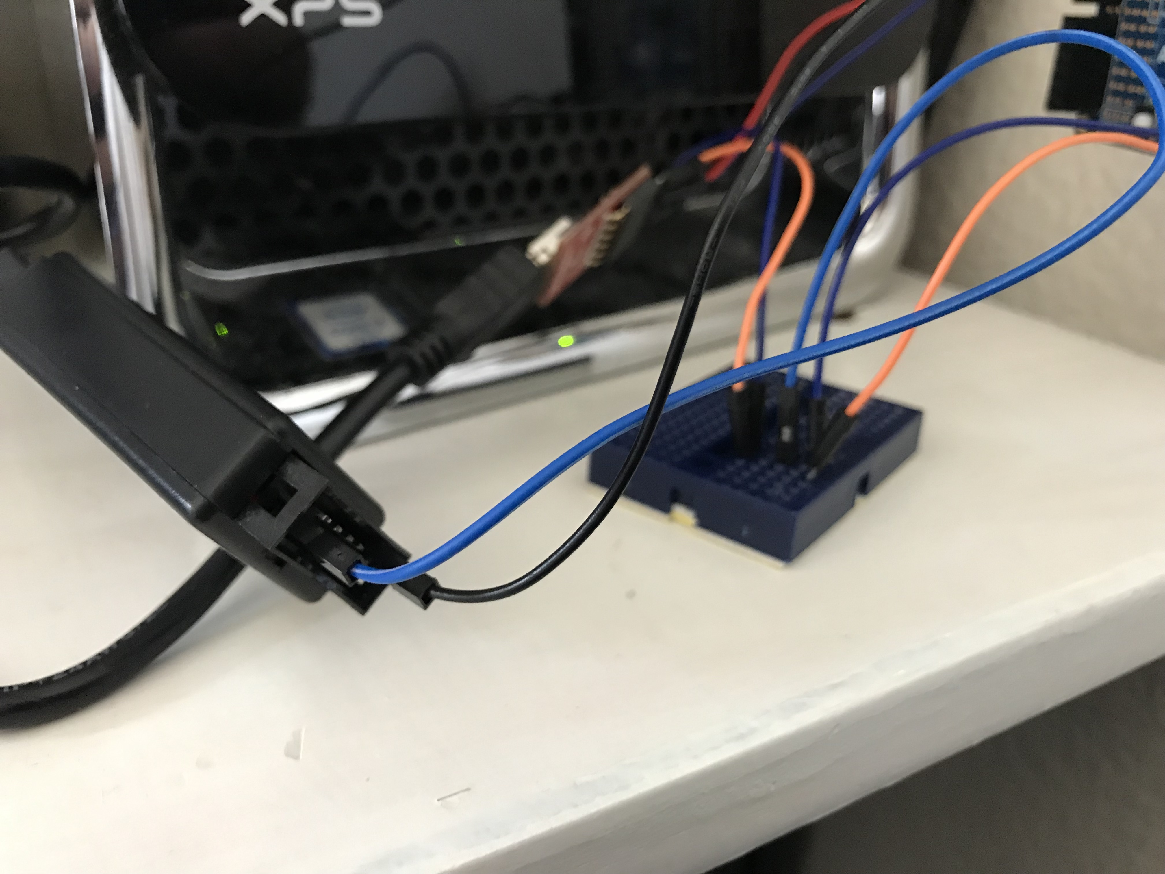

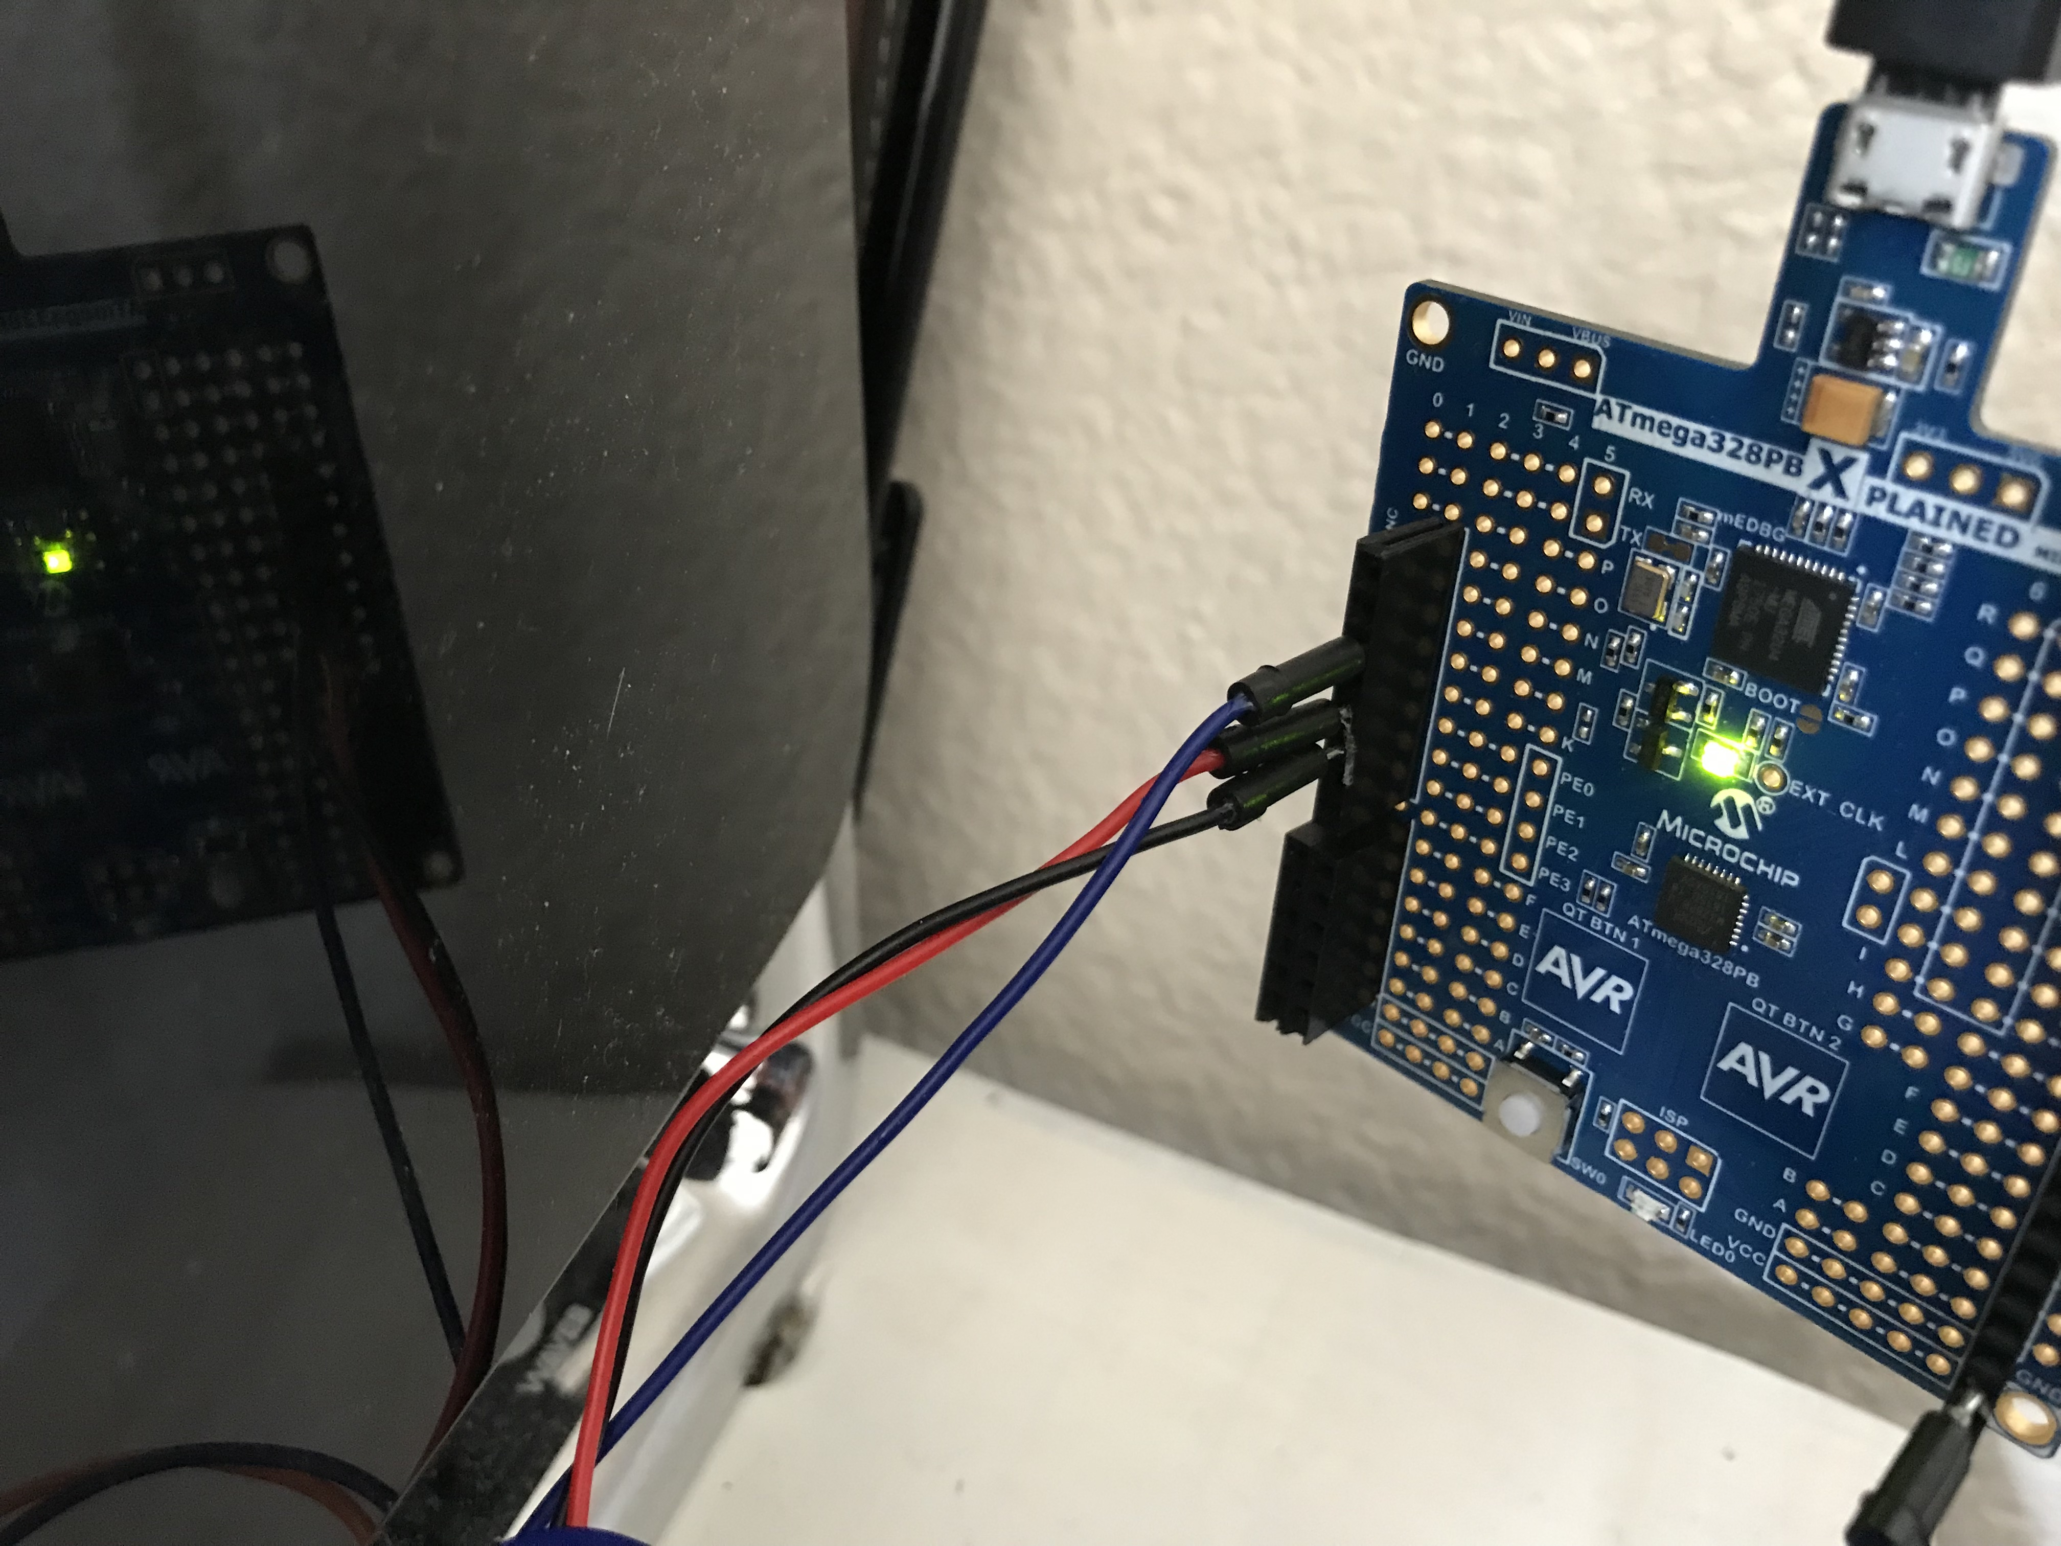

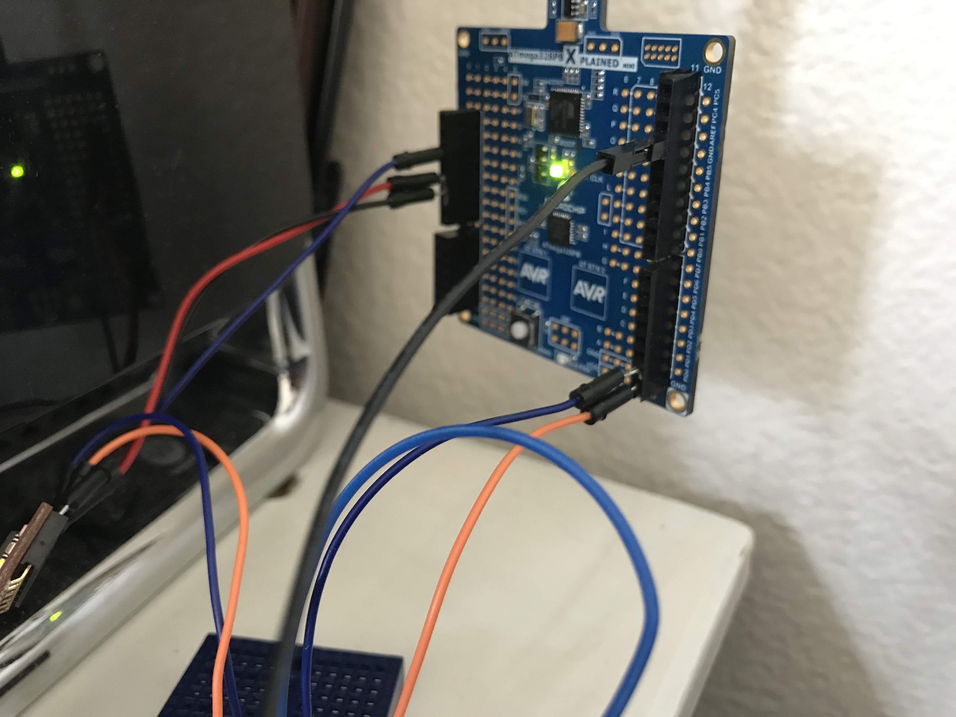

1. **VIDEO LINKS OF EACH DEMO**

<https://youtu.be/Mps3w5uHI_M>

1. **GITHUB LINK OF THIS DA**

**Student Academic Misconduct Policy**

<http://studentconduct.unlv.edu/misconduct/policy.html>

“This assignment submission is my own, original work”.

Clayton Higbee